Public Notice – permanent closure of a portion of Orton Road

The Shire of Serpentine Jarrahdale gives public notice of its intention to request the Minister for Planning and Lands to permanently close a portion of Orton Road, Byford, a total of 5947 square meters as marked in grey (as below) in accordance with section 58(1) of the Land Administration Act 1997.

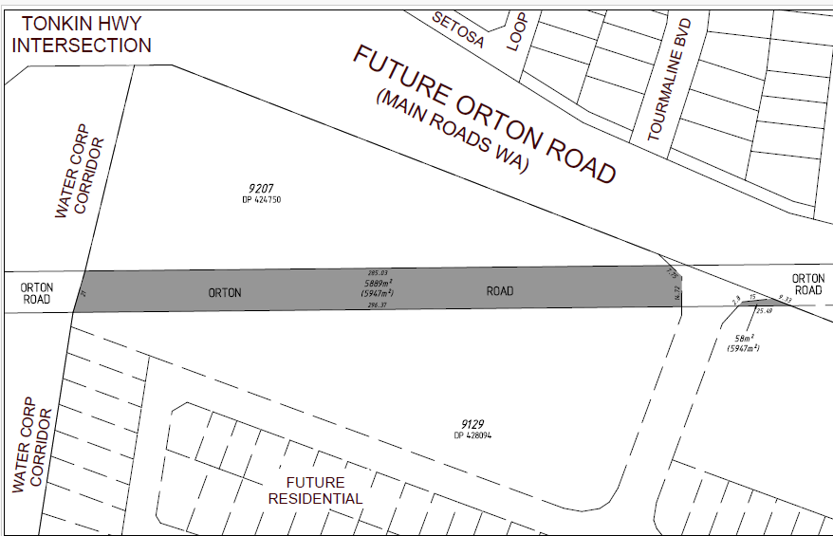

The proposed closure of a portion of the Orton Road road reserve will facilitate amalgamation with the adjoining land to form a commercial lot, as identified in the approved Glades Cardup Brook Precinct Local Structure Plan. This proposed road closure forms an integral part of the future development of the Byford town centre within the Glades Cardup Brook Precinct.

Planning for the Glades Cardup Brook Development has identified the need for closure of this section of road reserve. The developer has received Shire approval for the engineering drawings and specifications relating to the realignment and construction of Orton Road from the future Tonkin Highway connection to Doley Road. Construction of this approved section of Orton Road is currently underway, with works scheduled to be completed in December 2025.

The Tonkin Highway Extension Project includes construction of a roundabout at the proposed intersection of Tonkin Highway and Orton Road, connecting to the realigned section of Orton Road currently under construction. The existing Orton Road road reserve that is the subject of this proposed closure is required to remain open until the Tonkin Highway extension and the Orton Road connection are completed and operational.

Once the Tonkin Highway extension is complete and the connection to the realigned Orton Road is operational, the existing section of Orton Road subject to this closure will become redundant. At that time, the physical road closure will proceed to ensure access and connectivity are maintained throughout construction. This is currently anticipated to occur in late 2028.

Submissions

Written submissions or feedback regarding the proposed closure are invited and must be received no later than 5.00pm on Tuesday April 28, 2026.

Submissions should be addressed to

Chief Executive Officer
Shire of Serpentine Jarrahdale
6 Paterson Street
Mundijong WA 6123
Email: info@sjshire.wa.gov.au

For further information, please contact the Shire on (08) 9526 1111, or email info@sjshire.wa.gov.au.

Paul Martin
Chief Executive Officer

