Discussion paper - Formal review of the existing Conservation Zone initiative to enable its possible expansion to other natural areas of high significance

Contents
1. Background
2. What is the Conservation zone?
3. Legislation regarding the conservation zone
4. Most recent scheme amendment to ‘Conservation zone’
5. Possible unintended consequences
6. Value of the Conservation Initiative
7. Areas for possible inclusion in the Conservation initiative
8. Questions for discussion and feedback

1. Background
The Corporate Business Plan identifies an action to “Conduct formal review of the existing Conservation Zone initiative to enable its possible expansion to other natural areas of high significance.” This is the purpose of this report.
There have been two applications for rezoning since 2000:
- Rezoning to Conservation zone Amendment 185 – L341 Balmoral road Jarrahdale
- Rezoning to Conservation zone Amendment 181 – L564 Scrivener road

2. What is the Conservation zone?
Conservation zoning allows landowners with areas of high conservation value to receive reductions in Council rates. The initiative has been established by Council to reward landowners who have retained and maintained bushland and wetland of high conservation value. Council recognises that nature conservation on private land is essential to maintaining the quality of life for all residents of the Shire and Serpentine River catchment.
To be eligible, landowners must demonstrate to Council that their bushland and/or wetland area is of high conservation value by meeting the criteria outlined below. All or portions of properties can be zoned conservation.
What are the benefits of being in the Conservation Zone?
Areas zoned Conservation in the Town Planning Scheme are rated at half the rate of Rural Zoned land (i.e. 50% rate reduction) where the original zoning of the land is Rural. Where original zoning is not Rural, rate relief will be assessed on a case-by-case basis.

How do I rezone my property to Conservation Zone?
Areas eligible to enter into the Conservation Zone can be nominated by the landowner or by Council. Landowners must state in writing that they agree to rezone their land and Council must establish that the land meets the criteria for conservation zoning before the formal process of rezoning can proceed.
The formal rezoning process involves changing the zone name and provisions for that land within the Town Planning Scheme from the previous zone type to the new zoning of Conservation. (e.g. Rural to Conservation). Council may consider covering the cost of rezoning fees and associated advertising and will provide other assistance where possible.
The rezoning process requires the preparation of a Town Planning Scheme amendment report and an environmental management plan which documents both what is on the land and what management practices are to be used by the owner to protect these environmental values.
The Town Planning Scheme amendment report and environmental management plan are considered by the Shire, the Western Australian Planning Commission and ultimately the responsible Minister for Planning as to whether approval will be granted.
Once the land is rezoned, Shire staff and the Community Landcare Centre may provide advice on the implementation of the environmental management plan.
When the land is sold, new owners may be able to make variations to the environmental management plan. However, because the conservation zoning remains, changes will only be permitted if they ensure the site’s continued protection.
What is the process to do a scheme amendment to re-zone the property?
Suitably qualified consultants need to be engaged to prepare the required Scheme Amendment documentation and associated technical appendices.
Once the required documentation has been prepared, a Scheme Amendment application must be lodged with the Shire for assessment. The Scheme Amendment application would be progressed by the Shire in accordance with the Planning and Development (Local Planning Schemes) Regulations 2015. This would include the advertising of the Scheme Amendment for public comment.
The Shire will make a recommendation on the Scheme Amendment application and it will be referred to the Western Australian Planning Commission for assessment. The Scheme Amendment application is ultimately required to be approved by the Minister.
What documents / studies are required for a scheme amendment?
An amendment to a local planning scheme must be accompanied by all documents necessary to convey the intent and reasons for the amendment. A rezoning to the Conservation zone may require the following documents/studies to be prepared:
• Scheme Amendment Report
• Environmental Management Plan
• Bushfire Management Plan

How much does it costs to do a scheme amendment?
It may cost approximately $30,000 – $40,000 to prepare a scheme amendment with the associated technical studies listed above for a rezoning to the Conservation zone.
How long will it take?
The Scheme Amendment process should take approximately 12 to 18 months to be approved.
Criteria for selection of High Conservation Areas
The following criteria were developed to guide the selection of bushland and wetland areas which are eligible for Conservation Zoning:
Condition – the area and its vegetation are in a relatively undisturbed condition. Considerations include weed impact, fire history and past land uses.
Representation – the level of protection provided to the natural communities present on the subject land within reserves and covenanted private lands elsewhere.
Adequacy – the likelihood that natural communities and processes will be able to sustain themselves. Considerations include the size of the conservation area (usually needs to be greater than 10 hectare), its area to perimeter ratio and intensity of management that is being committed to.
Landowner commitment and ability – the landowner’s demonstrated intent, commitment and ability to conserve the environmental values on the subject land.
Special consideration may be given to areas which contain:
- ‘threatened ecological communities’
- rare or restricted plant species or ecological communities;
- breeding habitat for Declared Rare or Priority Listed Fauna;
- important wildlife corridors between other areas of conservation value.

Other considerations regarding the Conservation zoning
An internal document was produced in 1999 that considered a number of other matters in this regard.
Landowners who make a commitment to conservation on their land through the Shire conservation zoning process may face some or all of the following financial disincentives under the current taxation system:
- Loss of available land from which to earn an income;
- Loss of opportunity to offset land management expenses against earnings;
- Loss of 31% farming concession rebate on rates (however 50% rate reduction granted);
- Affected area of land may be then subject to Land tax.
The State Government provides land tax exemption to conservation covenanted properties; this exemption will apply to those covenanted under the state system administered by the Department of Biodiversity, Conservation and Attractions or by the National Trust of Australia (WA)
A covenant can only detail what a landowner cannot do on their land. The National Trust offers a support service to covenanting landowners in the development of a Bushland Owners Manual. This manual outlines objectives in the management of the subject bushland, key issues to address and a monitoring strategy to assess actions presented in the management plan.
The National Trust Management Plan may be an adequate management plan for Conservation Zoning purposes as described under the Town Planning Scheme.
This Shire has shown leadership and innovation in developing and implementing the conservation zoning initiative. Its alignment with the Town Planning Scheme provides a level of statutory protection at least equivalent to a State Government covenant, a management plan associated with the Shire’s conservation zoning has the flexibility to include both what cannot be done and what must be done in order to manage the land appropriately for conservation.

3. Legislation regarding the conservation zone
3.1 Shire of Serpentine-Jarrahdale Town Planning Scheme No. 2
The provisions within the Town Planning Scheme relating to the Conservation Zone are provided following:
5.14 CONSERVATION ZONE
5.14.1 The purpose and intent of the Conservation Zone is described within the Council’s Rural Strategy as amended and adopted by Council and the State Planning commission dated April 1994.
5.14.2 A Conservation zone is intended to identify land that has a high conservation significance which includes private land with large stands of relatively intact remnant vegetation, all recognised wetlands of significance and some areas covered by the Department of Environmental Protection System 6 recommendations.
5.14.3 The private lands identified for conservation in the rural strategy are not intended for acquisition by the Council or State Government Agencies. Rather the general aim is to encourage and make it easier for landowners to protect and manage the conservation values present.
5.14.4 Before including land within the Conservation Zone Council will require the owners of the land to prepare a submission in support of its inclusion and any submission shall include those matters set down in sub-clause 5.9.3 of this Scheme.
5.14.5 A description of the land included in the Conservation Zone together with the uses permitted and any special provisions relating to the land are set out in Appendix 4D. such uses will generally be in accordance with the Rural Zone uses but will depend upon site survey and reference to land capability and other planning data.
Land uses selected will be on the basis that they will not conflict with, or they will contribute to the significance of conservation values present.
5.14.6 In addition to the provisions contained in Appendix 4D and other such provisions of the Scheme as may affect it any land which is included in the Conservation Zone shall be subject to the following conditions:
(a) The relevant guidelines contained within the Council Planning Guidelines for Nutrient Management dated May 1994 (as amended) shall apply to the use and development of land.
(b) A management plan for each Conservation Zone shall be drafted to Council’s satisfaction by the landowner with input from other relevant organisations and the landowner’s consultant where necessary.
(c) The management plan shall establish the limits for land use and criteria that any development will have to satisfy. The plan will form the basis for site management and future management decisions.
(c) The management plan shall, as appropriate, identify setbacks, buffer zones, and the required conservation management practices and other measures as deemed necessary to achieve a satisfactory standard of protection relative to the significance of conservation values present.
5.14.7 The implementation of a management plan by the landowner is a means of longer-term protection for the site and will be accompanied by a reduced Council rating on the land.
The incentives for these conservation measures will be a reduction in the general rural rate which shall be set at 50% unless otherwise amended by Council.
3.2 Shire of Serpentine-Jarrahdale Local Planning Scheme No. 3
The new planning scheme provides for a ‘Environmental Conservation” zone with the following objectives.
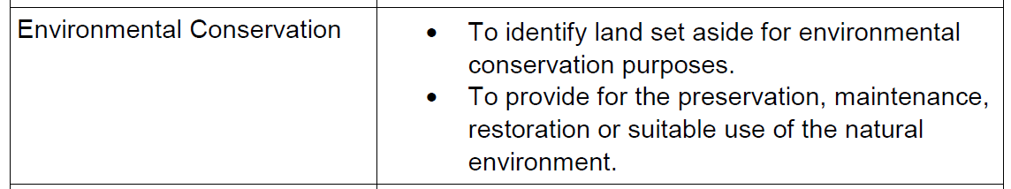
The following uses are D uses – ancillary dwelling, family day care, home business, home occupation, home office, industry cottage, single house meaning that the use is not permitted unless the local government has exercised its discretion by granting development approval;
The following uses are A uses – bed and breakfast, civic use, holiday house, rural home business, telecommunincations infrastructure means that the use is not permitted unless the local government has exercised its discretion by granting development approval after giving notice in accordance with clause 64 of the deemed provisions.
All other uses are X uses meaning that the use is not permitted by the scheme.
Schedule 4 of the scheme then requires Additional site and Development Requirements in the zone.
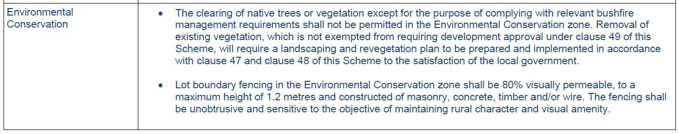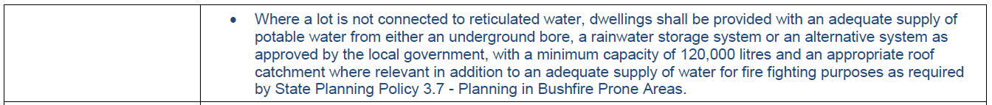
Furthermore the following objectives are stated for Reserves set aside for ‘Environmental Conservation’
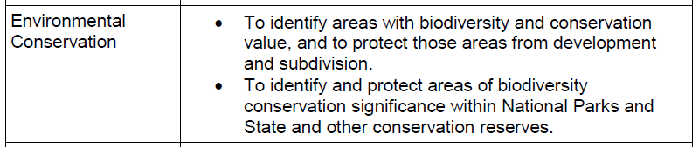
The Scheme also makes provision for a ‘Special Control Area 7’. Special control areas set out particular provisions which may apply in addition to the zone requirements and generally concern landscape, environmental, built form, and land and site management issues.
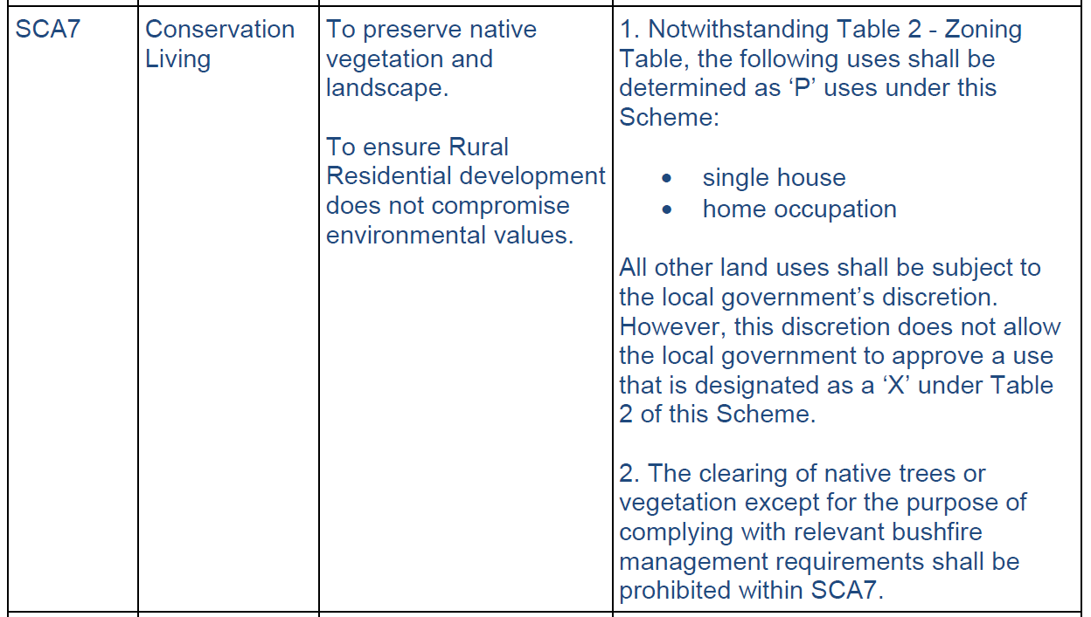
3.3 Local Planning Strategy
The Local Planning Strategy has an action that has informed the creation of SCA7 in the Local Planning Scheme No. 3.
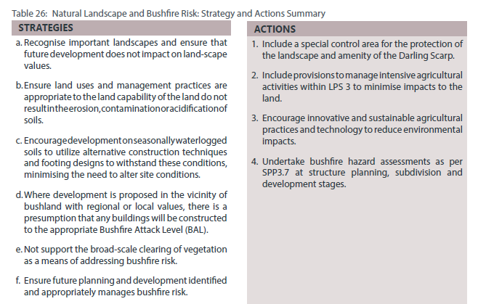
The Local Planning Strategy indicates which areas have important vegetation and biodiversity values that may have the potential for further conservation.
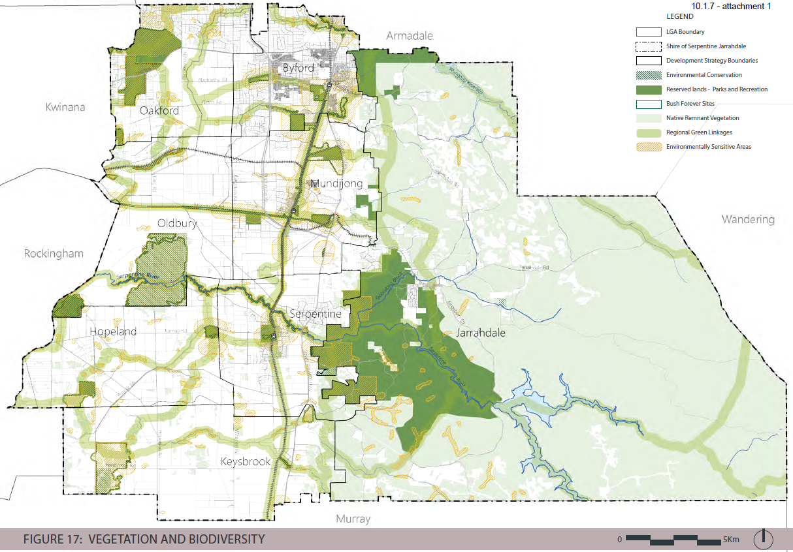

4. Most recent scheme amendment to ‘Conservation zone’
The most recent rezoning took place in December 2015 “OCM284/12/15 Final Adoption of Scheme Amendment 185 – Rezoning of Lot 341 Balmoral Road, Jarrahdale from ‘Rural’ to ‘Conservation’ (SJ1528)”. Council resolved to:
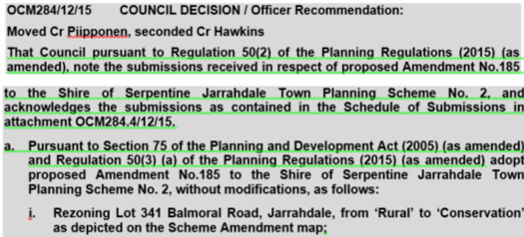
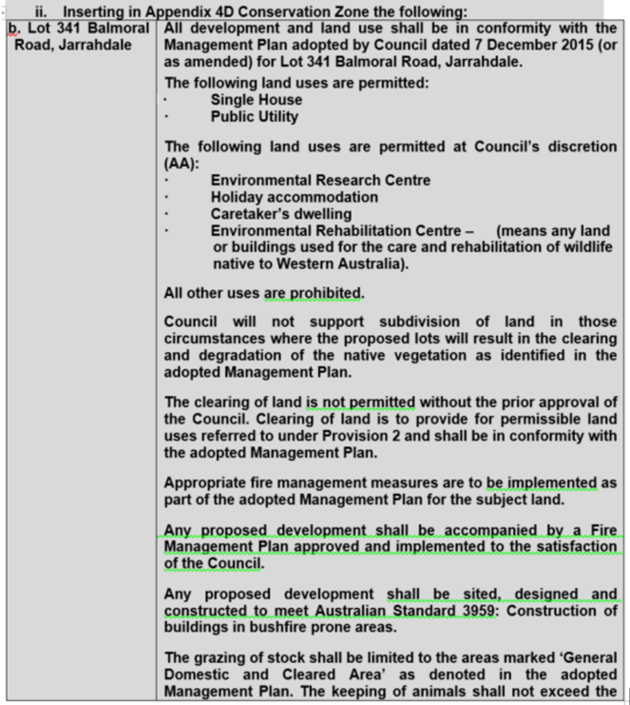
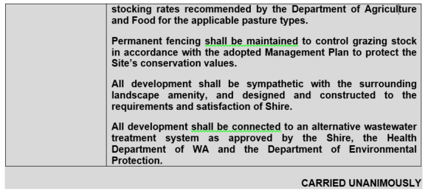
A management plan was required to accompany the amendment, which is available under IN14/18913.
5. Possible unintended consequences
Concern has been raised about the Special Use – Conservation Living zone in Old Dairy Court in Oakford. These properties had restricted use at subdivision due to conservation value. While these properties were granted the rate concession, this was not reflected of the planning framework and arguably should be addressed by either zoning conservation, or reviewing whether a rate concession should continue.
6. Value of the Conservation Initiative
6.1 Impact on Council rates – the Shire does lose out on half of the possible rates for any lot that is zoned for conservation in terms of the initiative, effectively meaning that the local government is subsidising the landowner through incentivising the conservation. The conservation value is difficult to determine and it could be argued that it cannot be readily quantified. It could, for example be worth more in tangible terms than the rate subsidy, or alternatively it could be worth less – measuring such benefit is yet to be undertaken in tangible terms.
The relatively low uptake of the initiative also means that the costs to Council are overall very low, compared to if it was a more broadly embraced program.
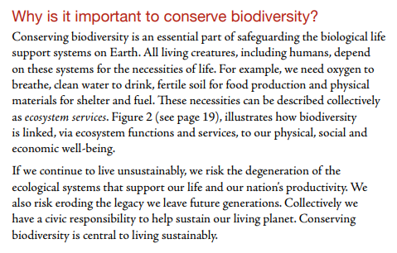
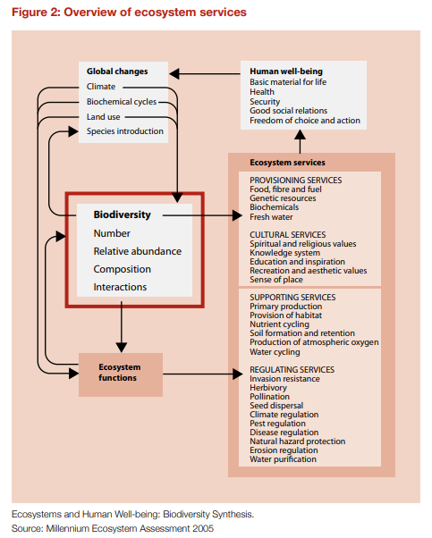
6.2 Impact in terms of area conserved – the conservation of native vegetation and fauna has a positive effect on almost every aspect of human life, physically and mentally. Australia’s Biodiversity Conservation Strategy 2010–2030 states:

6.3 Adherence to management plans – It is an unfortunate reality that the management plans that are put in place to ensure conservation for the areas are not always followed. This is especially true when the land is sold to other owners who do not have the same conservation mindset. This leads to compliance matters that needs to be addressed by Shire’s officers. Continued inspection and enforcement actions will be required to ensure that the conservation values are adhered to, which is a further cost of the program on the local government.

7. Areas for possible inclusion in the Conservation initiative
The areas indicated with a star could be considered for the “Conservation initiative”. Only areas that are in private ownership, where the owner agrees to have their land earmarked for this initiative would be included.
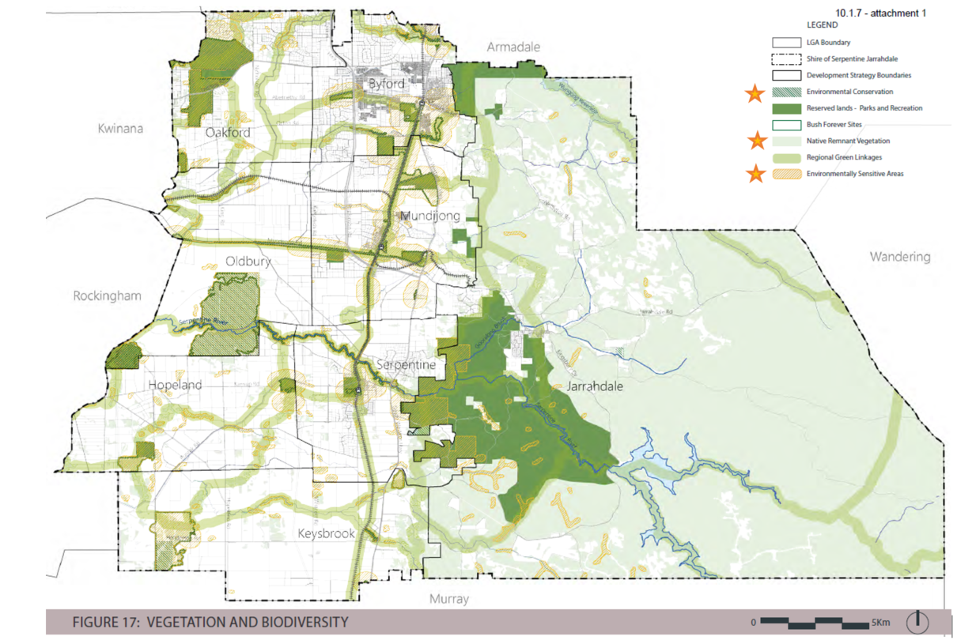

8. Questions for discussion and feedback
The above information is a collection of existing information for the Shire document library. It helps to set the context to further engagement with the community, on the future of the conservation zone program for the Shire. With this in mind, the Shire is seeking feedback from its community on the following questions:
Q1 There are currently very few lots in private ownership that have a “conservation” zoning that falls within this category. What could be done to try to increase landowner interest to consider joining the conservation program? Do current incentives provide enough encouragement versus the obligations that are associated with having land zoned as conservation?
Q2 What degree of Impact should be placed on prospective purchasers of land that is zoned conservation? There has been some discussion as to the restrictions that the zoning places on any new owners may be unreasonable, especially when ownership changes a number of times and the knowledge of what the conservation zone means, becomes lost through transfer. Should transfer in ownership affect the expectations that come with the conservation zone?
Q3 Should the conservation zone contemplate additional incentives, such as a clustered subdivision potential that enables a limited subdivision of now more than one lot to be created? Should further development potential be contemplated?
Q4 Should the criteria for considering land being included in the conservation zone be made more flexible / broader, to encourage greater degrees of uptake?
Q5 Should additional non-financial support be considered to further incentivise uptake of the conservation zone?
Q6 Should the Shire proactively encourage landowners to consider becoming part of the conservation zone initiative?
We seek your feedback to the above discussion questions, to enable officers to report to Council on new options for the conservation zone. We look forward to receiving your feedback.

