**Shire of Serpentine Jarrahdale**

**Public Health Plan**

**2025-2030**

**Table of contents**

1. **Acknowledgement of Country**
2. **Shire President’s Foreword**
3. **Executive Summary**
4. **Introduction**
5. **Local, State and Regional Context**
6. **Local Demographics**
7. **Health Profile**
8. **Community Consultation**
9. **Priorities**
10. **Local Food Health Plan**
11. **Objectives**
12. **Actions**
13. **Reporting**
14. **Acknowledgements**
15. **References**
16. **Acknowledgement of Country**

The Shire of Serpentine Jarrahdale acknowledges that the land of the district is the traditional country of the Noongar people. We recognise their cultural heritage, beliefs, and continuing relationship with the land, and pay our respects to Elders past, present and emerging.

1. **Shire President’s Foreword**

I'm pleased to present the Shire of Serpentine Jarrahdale’s Public Health Plan 2025-2030, a testament to the collaborative efforts of our community, Council, and stakeholders.

This Public Health Plan replaces the previous Shire of Serpentine Jarrahdale Health and Wellbeing Strategy 2020-2024 as our new plan to deliver healthy communities and enable residents to lead healthier lives within the Shire of Serpentine Jarrahdale.

A modern approach to public health requires a well-planned built environment that supports healthy behaviors and choices, and a vibrant social environment where people can live, work, learn, and play. Our goal is to create conditions where all citizens can thrive, now and in the future.

The plan is integrated with the Council Plan 2023-2033 pillars of thriving, livable, and connected communities, aiming to support sustainable growth, partnerships, and leadership. It seeks to protect and enhance our safe natural and built rural environment, ensuring access to essential services and facilities.

The plan has been thoroughly reviewed to identify the most significant health and wellbeing issues, as expressed by the Shire community. It outlines the actions we will take to address these issues, informed by consultation with the community and key health agencies, with the ability to measure our actions each year.

On behalf of the Council, I look forward to working with the Shire of Serpentine Jarrahdale community to see health and wellbeing for all.

1. **Executive Summary**

As Western Australians we enjoy one of the world’s highest life-expectancies, but the prevalence of underlying health issues is increasing, driving the need for a coordinated approach to public health plan at local level. This Public Health Plan 2025-2030 provides a strategic framework for improving the health and wellbeing of residents in the Shire of Serpentine Jarrahdale, to replace and supersede the previous Health and Wellbeing Strategy 2020-2024. The Plan has been prepared to align with the State Public Health Plan 2025-2030.

As the Shire continues its incredible growth as the fastest growing Local Government in Western Australia, challenges emerge. The Shire has a unique interface of rural residential properties, grazing land supporting agriculture and a vibrant equine industry, the magnificent state forest and rapidly growing urban areas with commercial and residential development alike. With such diversity, opportunities also emerge.

The key elements of the plan include the **vision**, which sets the overarching goal; **health profile**, a snapshot of the Shire’s health needs, **consultation** with the voice of the community, **priorities** and **objectives** guiding the focus areas; and **actions** for the Shire to deliver. Our health focus for the plan, in a snapshot:

|  |  |  |  |  |
| --- | --- | --- | --- | --- |
| Safe and Nutritious Food | Active places and spaces | Foster community cohesion | Reduce Smoke and Alcohol related harm | Improve Access to services |

*Our vision:*

***To foster a livable and connected community where everyone's health and wellbeing can thrive***

1. **Introduction**

A contemporary approach to public health planning calls for a more integrated approach to providing facilities, programs, and services that address not only environmental health but also chronic disease, mental health issues, communicable diseases, and other common community concerns. It involves collaboration within the Shire's various program service areas, with neighbouring Councils, the East Metropolitan Health Service, local community, and other local health service providers. A wide spectrum of actions influences public health, and all are crucial to achieving a healthier community. A coordinated effort from all public health partners and the community is needed. We are confident that this approach will strengthen collaboration across the Shire and the community, driving positive improvements to the health and wellbeing of the entire community.

The Public Health Act 2016 defines Public Health as:

* The wider health and wellbeing of the community; and
* The combination of safeguards, policies, and programs designed to protect, maintain, promote, and improve the health of individuals and their communities, and to prevent and reduce the incidence of illness and disability.

The draft State Public Health Plan for Western Australia 2025-2030 sets a fresh and ambitious vision for enhancing the health and wellbeing of all Western Australians. This plan emphasizes a strategic framework that integrates public health perspectives into broader planning efforts, ensuring a comprehensive approach to health improvement.

Public Health is recognized as a shared responsibility, with State Governments, non-government agencies, and Local Governments each playing a role in supporting and driving improvements to the health and wellbeing of the WA population, whether at a statewide or local community level. Local governments play a crucial role in enhancing and safeguarding public health. They handle regulatory tasks that are challenging for the WA government to manage due to their localized and diverse nature. These tasks include, planning and development approvals, pet management, parking regulations, and food and public health assessments.

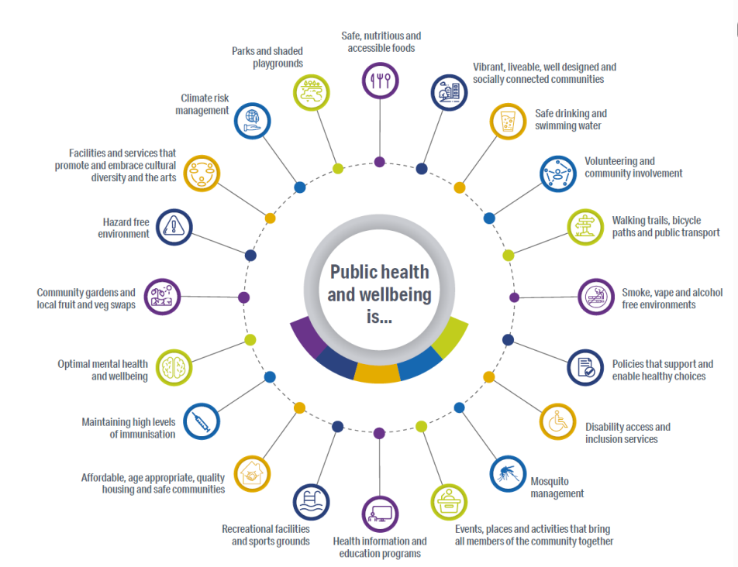

In addition, local governments are responsible for delivering various local services such as road maintenance, community facilities (like recreation facilities, public halls, and libraries), waste management, natural resource management, public space maintenance, and emergency and disaster response and recovery.

Through these roles, council officers and departments contribute to building strong, self-reliant, and resilient communities that meet both current and future needs. The figure below illustrates some of the local government's roles in improving community health and wellbeing.

1. **Local, State and Regional Context**

This Local Public Health Plan 2025-2030 is an informing strategy integrated into future plan process required under the *Local Government Act 1995* and in accordance with section 45(3) of the WA *Public Health Act 2016*. The Strategy has been prepared in alignment with three key local, state and national documents.

*Shire of Serpentine Jarrahdale Council Plan 2023-2033*   
Within the Shire’s integrated planning framework is the Shire of Serpentine Jarrahdale’s Council Plan 2023- 2033, representing the collaborative efforts of both Council and the community. This key document has a vision for creating a welcoming community where everyone feels at home, by delivering three pillars:

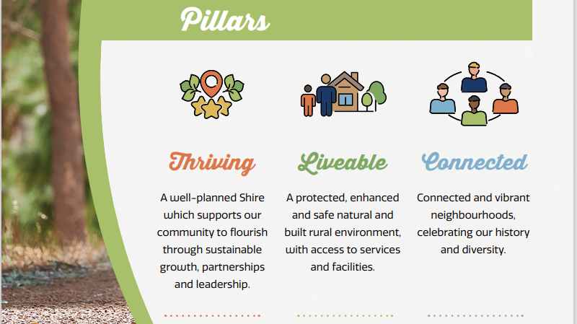

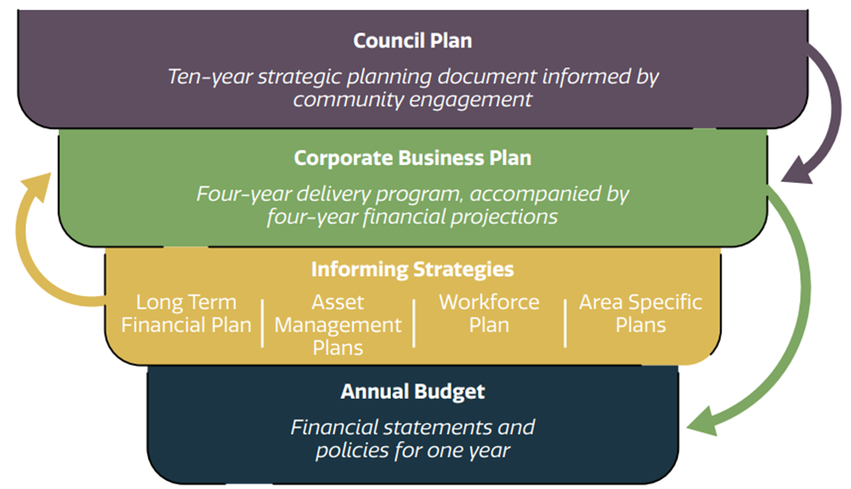

**<insert SJ Public health plan as an informing strategy>**

*State Public Health Plan for Western Australia 2024–2029*

The State Public Health Plan for Western Australia 2024–2029 vision the best Sustainable possible health, wellbeing and quality of life for all Western Australians-now and into the future. The State Public Health Plan for Western Australia 2024–2029 outlines several key priorities to improve public health. Here are the main objectives and priorities:

* Promote: Foster strong communities and healthier environments.
* Prevent: Reduce the burden of chronic disease, communicable disease, and injury.
* Protect: Safeguard against public and environmental health risks, manage emergencies effectively, and mitigate the health impacts of climate change.
* Enable: Strengthen public health systems and workforce, and leverage partnerships to support health and wellbeing.

*National Preventive Health Strategy 2021–2030*

The National Preventive Health Strategy aims to ensure that all Australians have the best start in life, Australians live in good health and wellbeing for as long as possible, health equity is achieved for priority populations and secure investment in prevention is increased. The National Preventive Health Strategy 2021–2030 outlines Australia’s key priorities for public health:

* Reducing tobacco use and nicotine addiction.
* Improving access to and consumption of a healthy diet.
* Increasing physical activity.
* Increasing cancer screening and prevention.
* Improving immunisation coverage.
* Reducing alcohol and other drug harm.
* Promoting and protecting mental health.

The National Study of Mental Health and Wellbeing offers critical insights into Australia's mental health landscape, revealing that:

* 42.9% of Australians aged 16–85 have experienced a mental disorder at some point in their lives.
* 21.5% had a mental disorder in the past 12 months, with anxiety being the most prevalent, affecting 17.2% of the population.
* Among Australians aged 16–24, 38.8% had a 12-month mental disorder.

**6. Local Demographics**

* 905km2 (Profile ID)
* 13 suburbs (Profile ID)
* 11,234 dwellings (2021 ABS Census data)
* 38,631 residents in 2024 (ABS Estimated Resident Population)
* 2.9 average household (2021 ABS Census data)
* 954+ Ha total area of reserves and public open space (Profile ID)
* 16,056 employed residents (62% full time, 31% part time) (2021 ABS Census data)
* 2,312 small businesses operating in the Shire (2021 ABS Census data)
* $1.25b Gross Regional Product (2021 ABS Census data)
* 52,691 Population forecast 2031 (Estimated Resident Population from the Australian Bureau of Statistics 2021)
* 67,939 Population forecast 2036 (Estimated Resident Population from the Australian Bureau of Statistics)
* 95,275 Population forecast 2046 (Estimated Resident Population from the Australian Bureau of Statistics)
* Higher proportion of children in SJ than in Greater Perth (2021 ABS Census data)
* 25.2% of people born overseas, most prevalent nationality overseas born being United Kingdom (2021 ABS Census data)
* Population density of 42.71 persons per km2 (2021 ABS Census data)
* 10.8% of people used a language other than English at home in 2021 (2021 ABS Census data)
* 96.1% of the residents are employed (2021 ABS Census data)
* Of those who are employed, 69.3% drive to work, whilst only 4.0% catch public transport, 1.5% ride a bike and 7.4% worked at home (2021 ABS Census data)
* The biggest employment categories are Technicians and Trade Workers (20.1%), Clerical and Administrative Workers (13.7%), Professionals (12.6%) and Community and Personal Service Workers (11.9%) (2021 ABS Census data)

<depict as infographics>

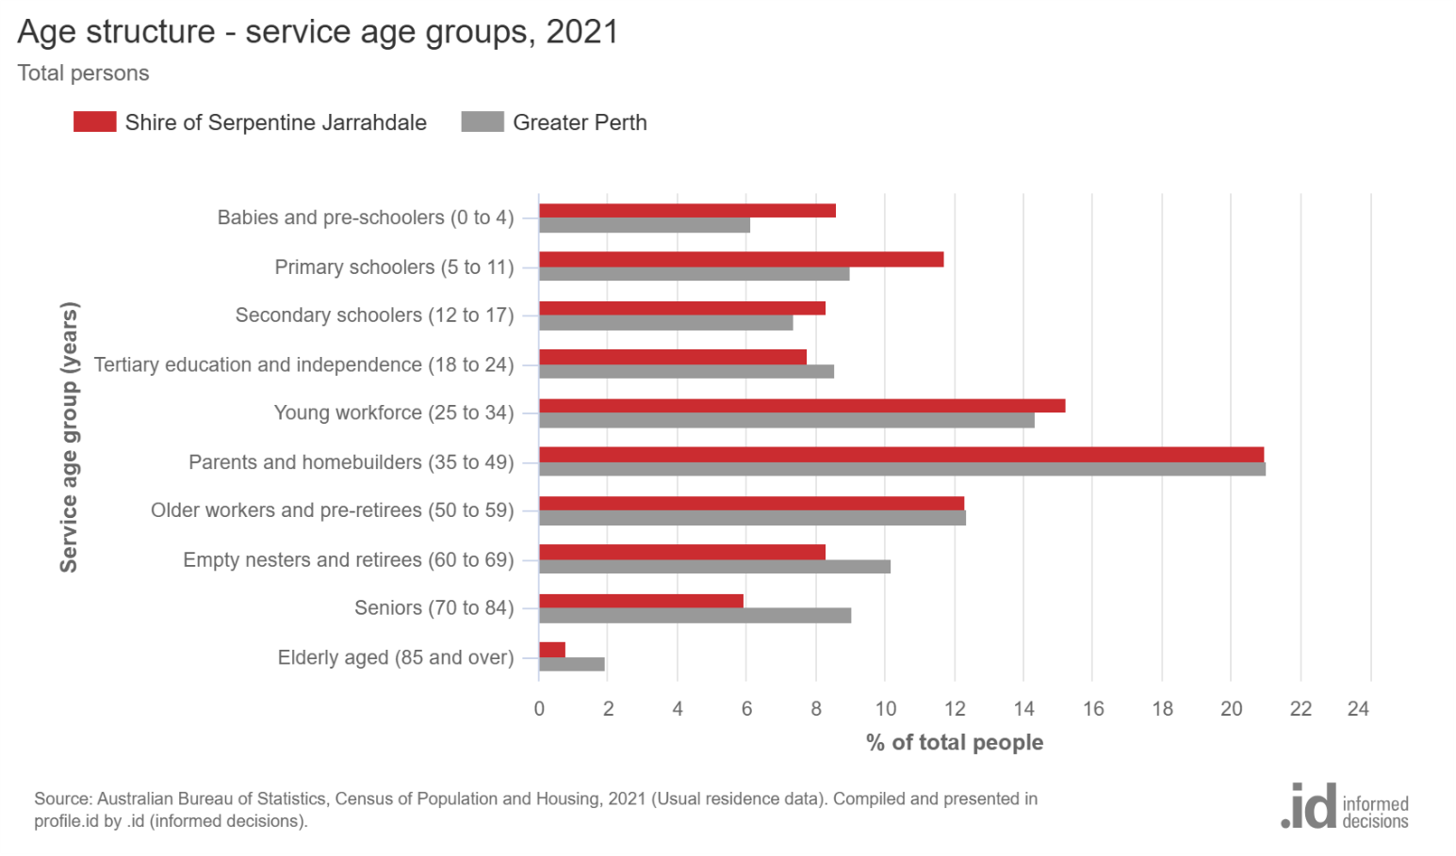

1. **Health Profile**

This strategy is built upon crucial local health and social data collected by the East Metropolitan Health Service (EMHS) and compiled into the Shire of Serpentine-Jarrahdale Community Health Profile for 2023. This profile includes data from various sources, such as the Australian Bureau of Statistics (ABS) and the Australian Institute of Health and Welfare (AIHW). The Shire’s Health Profile played a vital role in reviewing the strategy, alongside extensive community consultations that informed the framework, which includes vision, themes, missions, objectives, and actions for the next five years.

The purpose of this profile is to provide a comprehensive overview of the Shire’s population health, examining lifestyle and biomedical risk factors, as well as social and economic determinants of health. It also covers current health conditions, mortality rates, immunisation, and early childhood development. Mental health conditions including anxiety and depression are linked to higher mortality rates, poorer physical health, and increased exposure to lifestyle risk factors (Australian Institute of Health and Welfare [AIHW], 2024)

The 2023 health profile data indicates that the prevalence of adults aged 16 and above diagnosed with a mental health condition in the last 12 months is higher than the state average. Specifically, the prevalence of adults diagnosed with anxiety in the last 12 months is notably higher among females, with a rate of 15.54% compared to the state average of 11.19%.

Additionally, the prevalence of adults diagnosed with depression, stress, and high or very high psychological distress in the last 12 months is also higher than the state average, highlighting an opportunity to address mental health as a priority in the Shire.

Mental health is the most common long-term health condition, with 28.9% of the population reporting one or more health conditions. While specific rates are not detailed, chronic diseases (e.g., asthma, diabetes, cardiovascular conditions, cancer) are priorities in the profile, likely influenced by lifestyle and socioeconomic factors. (ID profile)

The data from Shire of Serpentine Jarrahdale 2023 Community Health Profile highlights several other health target areas for the SJ Shire community compared to the broader WA population. Firstly, poor diet and nutrition are evident, with only 7.45% of SJ Shire residents consuming the recommended serves of vegetables daily, compared to 8.39% in WA. Additionally, a significant portion of SJ Shire residents (27.12%) frequently eat from fast food outlets, higher than the WA average of 23.94%. These statistics suggest a need for targeted nutritional education and interventions to promote healthier eating habits within the SJ Shire.

Physical inactivity is another critical issue, with only 40.41% of SJ Shire residents meeting the recommended levels of physical activity per week, compared to 47.09% in WA. This indicates a potential area for public health initiatives to encourage more active lifestyles, such as community exercise programs, improved access to recreational facilities, and public awareness campaigns about the benefits of regular physical activity. Addressing physical inactivity can help reduce the risk of chronic diseases and improve overall community health. Additionally, addressing harmful alcohol consumption and smoking rates, which are also significant in the SJ Shire, can further contribute to improving the overall health and well-being of the community.

|  |  |  |  |
| --- | --- | --- | --- |
| **Community Health Profile – Top 5 Health Risk Factors** | | **SJ Shire**  **Persons**  **(%)** | **WA**  **Persons**  **(%)** |
| 1. Poor diet and nutrition | * Eats the recommended serves of vegetables daily      * Eats from fast food outlets at least weekly | **7.45**    **27.12** | 8.39    23.94 |
| 1. Physical inactivity | * Completed the recommended amount of physical activity per week | **40.41** | 47.09 |
| 1. Mental Health (last 12 months) | * Diagnosed with a mental health condition * Told by a doctor they have anxiety * Told by a doctor they have depression * Told by a doctor they have stress * Told by a doctor they have very high psychological distress | **19.49**  **12.32**  **12.62**  **11.66**  **11.72** | 15.53  9.33  8.22  9.47  8.64 |
| 1. Harmful Alcohol consumption | * Drinks at harmful levels that increase risk of long-term harm | **28.72** | 24 |
| 1. Smoking | * Adults who currently smoke | **11.40** | 10.69 |

Addressing smoking and the use of cigarettes which are also significant in the SJ Shire, can further contribute to improving the overall health and well-being of the community. E-cigarettes (electronic cigarettes), also known as vapes, are battery-operated devices designed to produce an aerosol that is inhaled into the lungs, many of which contain nicotine. Vaping among young people is strongly linked to the use of other tobacco products such as regular cigarettes, cigars, shisha and smokeless tobacco.

Research shows young people are three times as likely to start smoking if they vape. A targeted round of consultation was aimed to engage Youths on their experiences on vaping to inform this Plan.

1. **Community Consultation**

A key step in developing the Shire of Serpentine Jarrahdale's public health plan was ensuring robust community involvement. As part of the community consultation process, we engaged with community groups and various industries. We conducted a community perception survey to identify residents’ primary health risk concerns for themselves and their families. Additionally, we sought their ideas and suggestions on how the Shire could mitigate public health risks and enhance overall community health and wellbeing.

To gather comprehensive feedback, Shire Officers attended community events such as the Mundijong Farmers Market, the Recreation Centre, and spontaneous pop-ups at supermarkets and pharmacies. We also engaged with different age groups by visiting senior centres, retirement housing, and youth centres. QR codes linked to the survey were distributed at multiple locations, including the Byford Library, Community Resource Centre reception, public restrooms, pharmacies, shopping centres, and other Shire facilities.

Our efforts to engage the community reached over 406 community members. The survey was also accessible via social media and the Shire’s website and 165 individuals face-to-face.

In total, we received 233 responses to the survey: 24 from individuals aged 0-18, 129 from those aged 18-55, and 80 from those over 55.

These responses were instrumental in helping us set priority objectives based on the community’s input. Here are our findings

**Top Concerns:**

* 1. **Mental Stress and Crime:** Both ranked as the highest concerns.
  2. **Access to Services:** The second most significant concern.
  3. **Extreme Weather and Lifestyle-Related Obesity/Overweight:** 139 respondents highlighted this issue.
  4. **Smoking/Vaping:** 131 out of 234 respondents were concerned about this.
  5. **Alcohol/Drugs:** 130 out of 234 respondents noted this as a concern.

**Feedback about Shire’s Services:**

* 1. **Maintaining Parks, Reserves, and Public Open Spaces:** 202 out of 234 respondents prioritized this.
  2. **Providing and Maintaining Walking and Cycling Paths:** 194 respondents expressed this as a concern.
  3. **Providing and Maintaining Recreation Facilities:** 187 respondents highlighted this need.

Over 65 members of the Shire’s Youth ages 11-18, provided feedback on vaping. We asked the question: **Do you believe vaping is safer than smoking cigarettes?** 8 people said yes, 41 people said no and 7 people chose not to vote.

To inform the Local Food Actions of this Plan, a targeted round of consultation was undertaken in December 2024. Community members were invited to make their own smoothies on the Blender Bike at our counter, but first, they had to answer two questions:

1. Should Shire facilities and canteens promote healthy food and limit unhealthy food options? 100 people said yes, and 8 said no
2. Should the Shire allow unhealthy food and drinks to be advertised on Shire property? 12 people said yes, and 82 said no.

1. **Priorities**

After analyzing data from various sources, including community consultations, the Shire of Serpentine Jarrahdale health profile from East Metro Health Service, ID profile, Id, 2025 or Shire of Serpentine Jarrahdale id Community Demographic resources and other relevant data, we identified the community's highest priorities:

|  |  |  |  |
| --- | --- | --- | --- |
| **Prominent health risk statistics** | **Primary Demographic groups in SJ** | **Community’s Health concerns** | **Communities’ priority of Shire services** |
| Poor diet and nutrition | Higher proportion of 0-19- and 30–39-year-olds indicating young families are the highest population | Mental stress (including financial concerns) | Maintaining parks, reserves and Public open Spaces |
| Physical inactivity | Highest number of residents have English ancestry | Crime | Providing and maintaining walking and cycling paths |
| Mental Health (last 12 months) | Most spoken language after English is Punjabi | Access to services (Public transport, Shops health services) | Providing and maintaining recreation facilities |
| Harmful Alcohol consumption | Highest employment types relate to construction and mining | Extreme weather such as heatwaves, droughts | Advocating the better access to health service and public transport |
| Smoking  Larger percentage with Asthma (8.1% compared with 7.3) | Lower number of residents aged 60 plus compared to greater Perth | Lifestyle related obesity/ overweight | Enhancing access to trails (hiking, horse riding) |

1. **Local Food Action Plan**

An integral component of the Shire’s 2025-2030 Public Health Plan is Local Food Actions. The actions in this plan build upon and supersede the SJ Local Food Action Plan 2020-2024. This previous plan was the first of its kind from WA Local Governments and provided a coordinated approach to addressing key challenges specific to our local food environment.

Local food environments are all the processes involved in keeping us nourished. The impact in the availability, access and quality of food within a community or region and include the following factors:

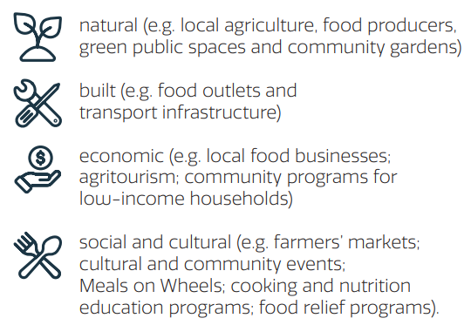

Local food environments that promote sustainable food systems also help to maintain food security and nutrition for future generations. Sustainable food systems must:

Within the Shire of Serpentine Jarrahdale, there is an extensive history of agricultural production with coexists with a continuing urban transition. As the Shire continues to develop, we recognise the importance of prioritising factors that influence food security, local food production systems, primary production and agriculture.

After analysing the data from community consultation and other sources, we discovered that healthy eating is one priority for developing local food actions. This Shire’s large geographical presents a challenge for connectivity and accessibility to healthy food, which is by limited availability of healthy options.

I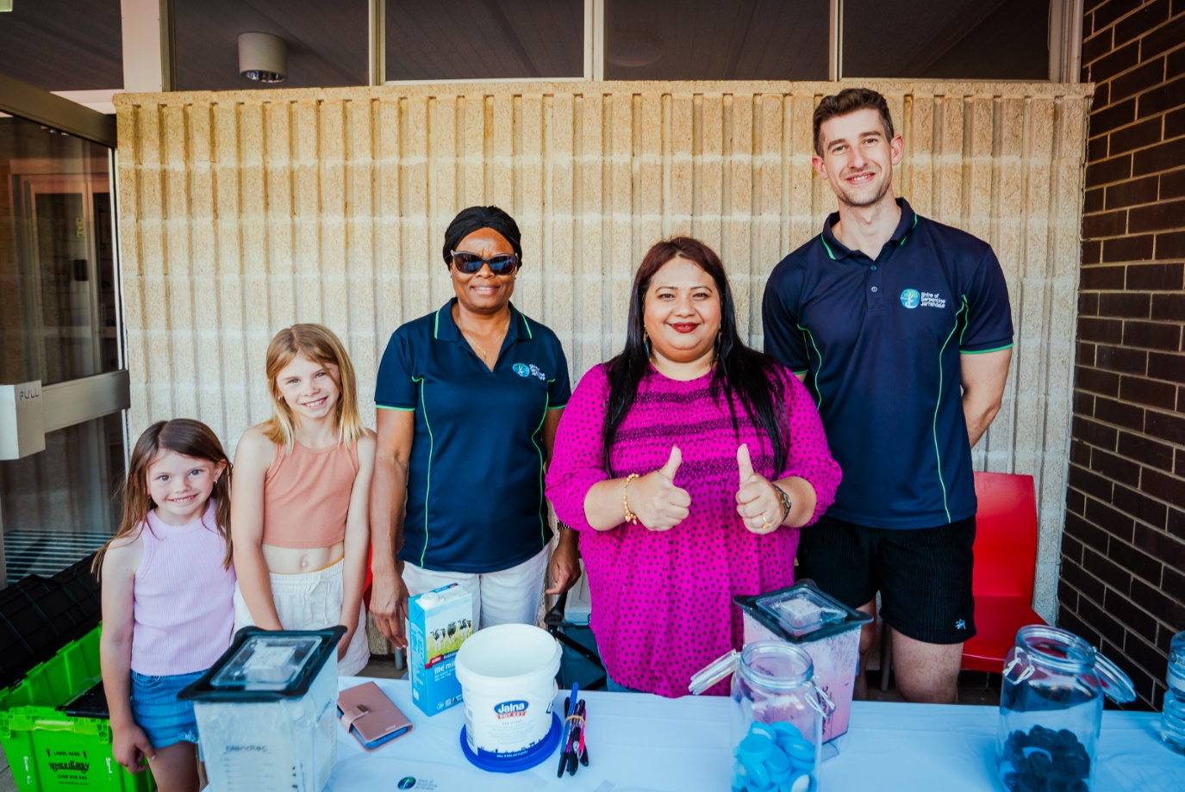

**Food Security and Peri-Urban Agriculture Advisory Group**

Recognising the need for a coordinated approach to local food actions, Council has resolved to form a Food Security and Peri-Urban Agriculture Action Group within the Shire of Serpentine Jarrahdale. Group member representation with be formed with relevant stakeholders from the Food and Farm Alliance, Peel Development Commission, education sector, local producers, local businesses and not local not for profit groups all of which that are involved in local needs of food security. The group will provide a voice to Council in the setting of policy, strategic direction and actions specific to food production. The aim of the Group is to work collaboratively with the Shire on matters relating to food security, food policies and regenerative agriculture – a strong connection to achieve the objectives of the Public Health Plan 2025-2030.

1. **Objectives**

|  |  |  |  |
| --- | --- | --- | --- |
| **Pillars** | **Thriving**  (individual health based) | **Livable**  (Place / environment based) | **Connected**  (community collective based) |
| **Mission statements** | **Enabling residents' health and wellbeing to flourish through active lifestyles and healthy choices,** | ***A protected, enhanced and safe natural and built environment, with access to services and facilities*** | ***Strengthening community connection so everyone feels at home*** |
| **Objectives** | 1. **Increase physical activity** 2. **Empower residents to make informed healthy choices (and reduce unhealthy behaviours such as smoking, drinking, anti-social behaviour)** 3. **Improve mental health and wellbeing.** | 1. **Improve transport options (including active transport) and access to services** 2. **Provide spaces that enable health, wellbeing and inclusion** 3. **Take measures ensure the safety and sustainability of the built and natural environment** | 1. **Provide programs to improve health and wellbeing for all** 2. **Enhance opportunities for social inclusion of everyone in our diverse community** |
| **Local Food Objectives** | **9. Improve access to; and intake of healthy nutritious food for everyone in the community** | **10. Enhance the local food network and sustainable agriculture in urban, peri-urban and rural environments** | **11. Grow community connection through learning, sharing and growing healthy sustainable food** |

1. **Actions**

The health and wellbeing of a person, a community and the environment are inter-related. We have recognized that some projects and actions can achieve a number of objectives by listing secondary objectives in brackets.

|  |  |  |  |  |  |  |  |  |  |
| --- | --- | --- | --- | --- | --- | --- | --- | --- | --- |
| **Objectives**  **(secondary objective)** | **Project/ activity** | **Action** | **Resources** | **Responsibility** | **Timeframe** | | | | |
| 25/  26 | 26/  27 | 27/  28 | 28/  29 | 29/  30 |
| **Increase physical activity**  **(4) (5)** | Map and promote walking, cycling and running routes | Promote existing walking and cycling routes between schools, shopping precinct and food outlets | Revise the Shires [Get-Active-Outdoors-Guide-2017.pdf](https://www.sjshire.wa.gov.au/Profiles/sj/Assets/ClientData/Documents/Page-Centre/Community/Get-Active-Outdoors-Guide-2017.pdf)  [Your Move | Organisations](https://yourmove.org.au/organisations)  Identify neighbourhood routes  Investigate the use of Strava | Environmental Health | X | X | X | X | X |
| **Increase physical activity**  **(7)** | Increase physical literacy | Provide programs to increase physical activity | Promote [Your Move | Schools](https://yourmove.org.au/schools)  [Homepage | Heart Foundation Walking](https://walking.heartfoundation.org.au/)  [Injury Matters](https://www.injurymatters.org.au/)  [Couch to 5k - C25K Running Program](https://c25k.com/)  Provide support for sporting clubs and recreation cohorts | Sports and Recreation  Community development  Environmental Health | X | X | X | X | X |
| **Empower residents to make informed healthy choices (and reduce unhealthy behaviours such as smoking, drinking, anti-social behaviour)**  **(5) (7) (8)** | Activate Byford Train station precinct | Provide activities, events and programs in the Byford Train station public realm to promote vibrancy and prevent antisocial behaviour | Byford train station public open space strategy  [Byford Rail Extension Community Priorities Fact Sheet.pdf](https://www.metronet.wa.gov.au/Portals/31/Project%20Documents/Byford%20Rail%20Extension/Byford%20Rail%20Extension%20Community%20Priorities%20Fact%20Sheet.pdf) | Community Activation  Public Health Officer  Community Safety officer | X | X | X | X | X |
| **Increase physical activity**  **(5) (7) (8)** | Kiernan Park Sports Precinct | Construct Stage 1A of the Keirnan Park Sports Recreation Precinct – AFL / cricket oval, pavilion and supporting infrastructure | [Keirnan Park Recreation and Sporting Precinct » Projects » Shire of Serpentine Jarrahdale](https://www.sjshire.wa.gov.au/projects/keirnan-park-recreation-and-sporting-precinct) | Project Management | X | X | X | X | X |
| **Empower residents to make informed healthy choices (and reduce unhealthy behaviours such as smoking, drinking, anti-social behaviour)**  **(7)** | Alcohol related harm | Provide programs to reduce alcohol related harm | [Go Dry this July](https://www.dryjuly.com/)  [Alcohol. Think Again | Reducing Alcohol-Related Harm & Health in WA | Alcohol Think Again](https://alcoholthinkagain.com.au/)  [The Alcohol and Drug Foundation - Alcohol and Drug Foundation](https://adf.org.au/) | Environmental Health |  |  |  |  |  |
| **Empower residents to make informed healthy choices (and reduce unhealthy behaviours such as smoking, drinking, anti-social behaviour)**  **(7)** | Smoke related harm | Provide education and programs to reduce tobacco and e-cigarette use  Audits vape stores  Install smoke and vape free signage on local government property and public places | [Get Started On Your Quitting Journey | Make Smoking History](https://www.makesmokinghistory.org.au/)  [Quit Support | Make Smoking History](https://www.makesmokinghistory.org.au/quit-support)  [Clear the Air resources](https://www.cleartheair.org.au/)  [The Alcohol and Drug Foundation - Alcohol and Drug Foundation](https://adf.org.au/) | Environmental Health | X | X | X | X | X |
| **Take measures ensure the sustainability of the built and natural environment**  **(7)** | Climate change | Implement the actions Council has approved through the Climate Change Strategy and Action Plan, with specific focus on those that increase mental health and wellbeing. | Climate Change Resource Fund | Across departments | X | X | X | X | X |
| **Take measures ensure the sustainability of the built and natural environment** | Reserve management | Implement the actions that Council approved in the Reserve Management Plans that focus on the maintenance of natural reserves under the control of the Shire. | Annual budget for maintenance for Operations, Urban Greening Grants | Operations  Across departments | X | X | X | X | X |
| **Take measures ensure the sustainability of the built and natural environment**  **(7) (8)** | Waste education | Provide community education programmes, workshops and events on sustainable waste minimisation and management practices | Bunting making workshops,  home composting,  innovative reuse or recycling | Waste | X | X | X | X | X |
| **Take measures ensure the sustainability of the built and natural environment**  **(8) (10)** | Jarrahdale Trails centre | Development of a Trails Centre that will provide a flexible space fulfilling roles of a Trails Centre, Visitor Centre, Attraction and Admin Service Centre. | [Jarrahdale_Trail_Centre.pdf](https://www.sjshire.wa.gov.au/Profiles/sj/Assets/ClientData/Documents/Jarrahdale_Trail_Centre.pdf)  [Delivery of a new trails centre for Jarrahdale. » Shire of Serpentine Jarrahdale](https://www.sjshire.wa.gov.au/our-shire/advocacy-2025/delivery-of-a-new-trails-centre-for-jarrahdale) | Economic development | X | X | X | X |  |
| **Take measures ensure the safety and sustainability of the built and natural environment** | Reduce occurrence of illegal dumping | Take measures to prevent the occurrence of illegal dumping by increasing opportunities for sustainable waste management and increasing monitoring and enforcement | [Keep Australia Beautiful](https://kab.org.au/)  [Community Litter Grants | Western Australian Government](https://www.wa.gov.au/service/environment/environment-information-services/community-litter-grants)  [Litter Prevention Strategy for WA 2020-25](https://www.wa.gov.au/system/files/2023-09/litter-prevention-strategy-wa-2020-25.pdf) | Community Safety  Waste | X | X | X | X |  |
| **Take measures ensure the safety and sustainability of the built and natural environment**  **(3) (5)** | CCTV subsidy program | Continue to provide the CCTV subsidy program and promote other programs to increase a sense of safety and security in the Shire | [Apply for a Safety and Security rebate | Western Australian Government](https://www.wa.gov.au/service/community-services/community-support/apply-safety-and-security-rebate)  [CCTV Subsidy Program » Shire of Serpentine Jarrahdale](https://www.sjshire.wa.gov.au/community/your-community/community-safety/cctv-subsidy-program.aspx)  [Community Safety and Crime Prevention Plan 2023-27](https://www.sjshire.wa.gov.au/Profiles/sj/Assets/ClientData/Community_Safety_and_Crime_Prevention_Plan_2023-2027_-_Final.pdf) | Community Safety | X | X | X | X | X |
| **Improve transport options, including active transport and access to services**  **(1)** | Provide cycling ways within the Shire and linking to the Perth metro | Revise the Shires Walking and Cycling plan to prioritise development of cycle links into the Shire | [SJ Cycling and Walking Plan](https://www.sjshire.wa.gov.au/Profiles/sj/Assets/ClientData/Documents/Uploads/ClientDataUploads/E19_11751__Shire_of_Serpentine_Jarrahdale_SJ_-_Cycling_and_Walking_Plan_-_OCM_Agenda_Item_-_Attachment_1_-_GHD_Walking_and_Cycling_Plan.pdf)  [Planning and designing for active transport](https://www.transport.wa.gov.au/activetransport/planning-and-design-guidance.asp)  [Your Move | Your Move: More Ways to Get There - Department of Transport](https://yourmove.org.au/)  [Long-term cycle network](https://www.transport.wa.gov.au/activetransport/long-term-cycle-network.asp) | Engineering Services | X | X | X |  |  |
| **Improve transport options, including active transport and access to services**  **(1)** | Serpentine footpath | Construct a footpath connecting the Serpentine Townsite to South Western Highway and to Serpentine Falls |  | Engineering Services | X | X |  |  |  |
| **Provide spaces that enable health, wellbeing and inclusion** | **Parks a** | **TBC – Rod and Natalie are finalising a draft action regarding a playground** |  |  |  |  |  |  |  |
| **Provide spaces that enable health, wellbeing and inclusion** | Public Health impact assessments for planning proposals | Assess strategic planning applications such as structure plans and subdivisions  With consideration toward the objectives of the SJ PHP | [community_walkability_checklist.pdf](https://assets.contentstack.io/v3/assets/blt8a393bb3b76c0ede/blt2dfe350cba4f9ef5/65fcaaf08330b3586c030fb2/community_walkability_checklist.pdf)  [Healthy Active by Design | Urban Health Resources](https://www.healthyactivebydesign.com.au/)  [Built environment and heart health | Heart Foundation](https://www.heartfoundation.org.au/healthy-living/physical-activity/physical-activity-built-environment)  [Healthy Streets | Making streets healthy places for everyone](https://www.healthystreets.com/)  [Connecting Communities Fund | RAC WA](https://rac.com.au/about-rac/advocating-change/initiatives/connected-communities/connected-communities-fund) | Environmental Health  Strategic Planning | X | X | X | X | X |
| **Take measures ensure the safety and sustainability of the built and natural environment**  **(7)** | Provide regulatory services | Continue to provide regulatory services to protect the health and amenity of the community, the natural environment and safety of the built environment | *Public health Act 2016*  *Food Act 2008*  *Building Act 2011*  *Planning and Development Act 2005*  *Local Government Act 1995 and Shire local laws* | Statutory Planning and compliance  Building Services  Environmental Health  Community Safety |  |  |  |  |  |
|  | Support and collaboration with Health hub |  |  |  |  |  |  |  |  |
| **Provide programs to improve health and wellbeing for all**  **(8)** | Support community members most in need | Partner with relevant outreach organisations to facilitate support to members of the community experiencing hardship | [Homelessness we care](https://www.homelessnesswecaresjs.com.au/)  [Food bank](https://www.foodbank.org.au/WA/)  [Financial Wellbeing Collective](https://thefwc.org.au/emergency-relief/) | Community Safety  Community Development | X | X | X | X | X |
| **Enhance opportunities for social inclusion of everyone in our diverse community**  **(5)** | Housing affordability | Continue to work with State government and developers to increase the provision of affordable housing in the Shire. | Infrastructure advocacy through political and other state structures | Strategic planning, Engineering, Building | X | X | X | X | X |
| **Enhance opportunities for social inclusion of everyone in our diverse community**  **(7)** | Community events | Provide a variety of inclusive and affordable community events promoting wellbeing for all | Promote low cost or free alcohol and smoke / vape free events  Encourage healthy choices  Encourage sustainable practices (Go2cup, Switch your thinking)  Cater for our diverse community (youth programs, seniors, harmony week etc) | Environmental Health | X | X | X | X | X |
| **Enhance opportunities for social inclusion of everyone in our diverse community** | Friendly neighbourhoods | Expand the community BBQ program and empower neighbours to develop a strong community atmosphere | [Friendly Neighbourhoods Grant » Shire of Serpentine Jarrahdale](https://www.sjshire.wa.gov.au/community/your-community/sj-community-grants-program/friendly-neighbourhoods-grant.aspx) | Community Safety  Environmental Health | X | X | X | X | X |
| **Provide programs to improve health and wellbeing for all**  **(8)** | Mental health | Collaborate and deliver mental health awareness | [Home - Act Belong Commit | Promoting Positive Mental Health in WA](https://www.actbelongcommit.org.au/)  [Strong Spirit Strong Mind | Home | Strong Spirit Strong Mind](https://strongspiritstrongmind.com.au/)  [Home | Mental Health Commission](https://www.mhc.wa.gov.au/)  [24/7 Support for Anxiety, Depression and Suicide Prevention. - Beyond Blue](https://www.beyondblue.org.au/)  [Kids Helpline | Phone Counselling Service | 1800 55 1800](https://kidshelpline.com.au/)  [headspace National Youth Mental Health Foundation](https://headspace.org.au/)  [Black Dog Institute | Better Mental Health | Science. Compassion. Action.](https://www.blackdoginstitute.org.au/) | Community Development  Library services  Youth services | X | X | X | X | X |

|  |  |  |  |
| --- | --- | --- | --- |
| **Pillars** | **Thriving**  (individual health based) | **Livable**  (Place / environment based) | **Connected**  (community collective based) |
| **Local Food Objectives** | **9. Improve access to; and intake of healthy nutritious food for everyone in the community** | **10. Enhance the local food network and sustainable agriculture in urban, peri-urban and rural environments** | **11. Grow community connection through learning, sharing and growing healthy sustainable food** |

1. **Local Food Actions**

|  |  |  |  |  |  |  |  |  |  |
| --- | --- | --- | --- | --- | --- | --- | --- | --- | --- |
| **Objectives** | **Project/ activity** | **Action** | **Resources** | **Responsibility** | **Timeframe** | | | | |
| 25/  26 | 26/  27 | 27/  28 | 28/  29 | 29/  30 |
| **Improve access to; and intake of healthy nutritious food for everyone in the community**  **(2) (11)** | Healthy Advertising policy | **Investigate and prepare a Policy around limiting Advertising unhealthy food and drink** | [Healthy-Advertising-Standards-Toolkit.pdf](https://cancerwa.asn.au/assets/public/2024/07/Healthy-Advertising-Standards-Toolkit.pdf)  [Australian dietary guidelines 1 - 5 | Eat For Health](https://www.eatforhealth.gov.au/guidelines/australian-dietary-guidelines-1-5)  [Healthy Advertising Policies – Nutrition & Health Innovation Research Institute](https://nhiri.ecu.edu.au/food-environments-team/information-environment-stream/healthy-advertising-policies/) | Environmental Health  Statutory Planning | X | X | X |  |  |
| **Improve access to; and intake of healthy nutritious food for everyone in the community**  **(2) (11)** | Healthy menu options policy | **Research and develop a Policy around the provision of healthy food menu options at Shire Facilities** | [Development of the Menu Assessment Scoring Tool (MAST) to assess the nutritional quality of food service menus](https://ro.ecu.edu.au/cgi/viewcontent.cgi?article=3134&context=ecuworks2022-2026)  [Traffic-lights-on-the-menu_New-HO.pdf](https://www.fueltogo.com.au/wp-content/uploads/2022/03/Traffic-lights-on-the-menu_New-HO.pdf) | Environmental Health | X | X | X |  |  |
| **Improve access to; and intake of healthy nutritious food for everyone in the community**  **(5) (11)** | Improve Shire kitchen facilities | **Upgrade Shire facility kitchens to support the provision of safe and healthy food options to the community** | [Apply for up to $5,000 Healthy Communities funding - Healthway](https://www.healthway.wa.gov.au/our-funding/healthy-communities-program/apply-for-up-to-5000/) | Facilities  Major Projects  Environmental Health | X | X | X | X | X |
| **Improve access to; and intake of healthy nutritious food for everyone in the community**  **(7)** | Food security | **Support initiatives that make healthy food accessible to all cohorts of the community, especially those most impacted by food insecurity** | [Foodbank | Ending Hunger in Australia](https://www.foodbank.org.au/?gad_source=1&gad_campaignid=325365861&gclid=EAIaIQobChMIpKqqitadjQMV6KVmAh2KGSMlEAAYASAAEgLH6fD_BwE)  [Byford Baptist Church Food market](https://www.byfordbaptist.org.au/about-us)  [Fair Food WA – WACOSS](https://www.wacoss.org.au/projects/fair-food-wa/)  [Join Grow It Local: Learn, Share & Grow Heirloom Veggies](https://growitlocal.com/)  Breakfast club for youth | Environmental Health  Community development | X | X | X | X | X |
| **Improve access to; and intake of healthy nutritious food for everyone in the community**  **(7) (11)** | Healthy and nutritious food | **Provide knowledge and access to residents to cook healthy meals** | Cooking with youths' program  [LiveLighter - Fruit and veg](https://livelighter.com.au/eating-well/healthy-eating/fruit-and-veg?utm_source=Google&utm_medium=cpc&utm_campaign=AUS_LL_FRUIT%26VEG&gad_source=1&gad_campaignid=18884812303&gclid=EAIaIQobChMIh_3t09edjQMVRcg8Ah1O_RnuEAAYASAAEgJeYPD_BwE)  [nom!](https://nom.org.au/?state=wa)  [Healthy Recipes: Thousands of perfect meals from Healthy Food Guide](https://www.healthyfood.com/healthy-recipes/)  [Healthy eating | Heart Foundation](https://www.heartfoundation.org.au/healthy-living/healthy-eating) |  | X | X | X | X | X |
| **Enhance the local food network and sustainable agriculture in urban, peri-urban and rural environments**  **(1) (2)** | Food trail | **Investigate and implement a food trail experience to promote local producers and fresh produce** | [Join Grow It Local: Learn, Share & Grow Heirloom Veggies](https://growitlocal.com/)  [lpp-15-exempted-development-policy - farm gate stalls](https://www.sjshire.wa.gov.au/documents/434/lpp-15-exempted-development-policy)  [Food & Wine Trails - Trails WA](https://trailswa.com.au/trails/trail-types/food-wine-trails) | Environmental health  Economic development | X | X |  |  |  |
| **Enhance the local food network and sustainable agriculture in urban, peri-urban and rural environments**  **(10) (11)** | Food Security and Peri- Urban Agriculture Advisory Group | **Support the creation of a Food Security and Peri-Urban Agriculture Advisory Group and the implementation of actions from that group** | [SJ Food and Farm Alliance](https://www.sjfoodandfarmalliance.com.au/)  [ARC Data Portal](https://dataportal.arc.gov.au/Landing)  [Food Community - Food Community](https://foodcommunity.com.au/home/)   1. Healthway: *No one left hungry! Place-based, community-led regional Western Australian initiatives to ensure healthy food for all.* Outcome expected in August. 2. Australian Research Council: *Creating innovative solutions for community food security.* Outcome expected probably November/December   [Home - Sustain: The Australian Food Network](https://sustain.org.au/)  [Peel Development Commission - Fastest growing region in WA](https://www.peel.wa.gov.au/) | Environmental Health | X | X |  |  |  |
| **Grow community connection through learning, sharing and growing healthy sustainable food** | Circular economy | **Investigate and enhance a local circular economy in SJ** | [Switch Your Thinking - Home - Switch Your Thinking](https://switchyourthinking.com/)  <https://wasteismyresource.com/>  [EarthWhile Australia - Soil Health Coaching & Workshops](https://www.earthwhileaustralia.com/)  [Circular economy - DCCEEW](https://www.dcceew.gov.au/environment/protection/circular-economy) |  | X | X | X | X | X |
| **Improve access to; and intake of healthy nutritious food for everyone in the community**  **(10)** | Community food gardening | **Improve community knowledge and access to produce healthy food at home and in the community.** | [Council Policy – Community Gardens](https://www.sjshire.wa.gov.au/documents/181/community-gardens-council-policy)  schools garden program  grow your own food workshops  [Slide 1](https://www.sjshire.wa.gov.au/Profiles/sj/Assets/ClientData/Organic_Gardens_in_Small_Places_on_the_Cheap_Presentation.pdf)  [WasteSorted Schools gardens | WasteSorted Schools | Waste Authority WA](https://www.wasteauthority.wa.gov.au/wss/teaching-resources/view/wastesortedschools-gardens)  [Edible_Garden_Planting_and_Maintenance_Guide.pdf](https://www.wasteauthority.wa.gov.au/images/resources/wss/Files/2019/10/Edible_Garden_Planting_and_Maintenance_Guide.pdf) | Environmental Health  Community development | X | X | X | X | X |

**13. Reporting**

Ongoing quarterly updates will be provided to Council through the Performance Planning Local Government system (PPLGS)

The Environmental Health Team will review this Strategy annually, and a report will be prepared for the Executive and Management Groups, Councillors and the Department of Health, adhering to the reporting requirements under the Public Health Act 2016.

**14. Acknowledgement**

The Shire would like to acknowledge the contribution of the East Metropolitan Health Services, WA Department of Health, Shire service teams who provided feedback on the services they provide which contribute to the health and wellbeing of the community, and the community members who provided valuable feedback to shape what we deliver in this Public Health Plan.

**15. References**

1. Australian Bureau of Statistics. (2020-2022). *National Study of Mental Health and Wellbeing*. ABS. <https://www.abs.gov.au/statistics/health/mental-health/national-study-mental-health-and-wellbeing/latest-release>.
2. Australian Institute of Health and Welfare. (n.d.). *Burden of disease*. Retrieved April 17, 2025, from

[Burden of disease Overview - Australian Institute of Health and Welfare](https://www.aihw.gov.au/reports-data/health-conditions-disability-deaths/burden-of-disease/overview)

3. Australian Institute of Health and Welfare. (2024). *Health Statistics 2024*.

[Australia’s health 2024: in brief, Summary - Australian Institute of Health and Welfare](https://www.aihw.gov.au/reports/australias-health/australias-health-2024-in-brief/summary)

4. Department of Health WA. Public health planning resources. Retrieved from <https://www.healthywa.wa.gov.au/sitecore/content/Corporate/Articles/N_R/Public-health-planning/Public-health-planning-resources>

1. Department of Health WA. Public Health Act 2016 (WA) guide for local government. Retrieved from <https://www.healthywa.wa.gov.au/~/media/Corp/Documents/Health-for/Public-health-planning/PHP-Guide-for-local-government.pdf>
2. .id (informed decisions). (2023). *Shire of Serpentine Jarrahdale population forecast*. Retrieved April 28, 2025, from

[Home | Shire of Serpentine Jarrahdale | Population forecast](https://forecast.id.com.au/serpentine-jarrahdale)

1. Western Australian Department of Health. (2024). *The WA Food ATLAS*. ArcGIS. (Food Atlas WA).

[The WA Food ATLAS (arcgis.com)](https://urldefense.com/v3/__https:/www.arcgis.com/apps/dashboards/b5e5b3f363e645ebaf026687e045ee02__;!!Lav448XFWxY!4_LIDcdxdorUWm07moEIJpYNZXogNjLAAU8zBqGc0v5LzYzk08QB31a8_PzMTpBuAZWNVg2b7vLC8LTP6ClY2cqwyF_rJjx1T88$)

1. North Metropolitan Health Service. (2024, October). A guide outlining the support North Metropolitan Health Service can provide north metropolitan local governments in public health planning. Retrieved from <https://www.nmhs.health.wa.gov.au/~/media/HSPs/NMHS/Documents/Public-Health/North-Metropolitan-Health-Service-Public-Health-Planning-Development-Guide.pdf>
2. South Metropolitan Health Service. (2017). Pathway to a healthy community: A guide for councilors and local government (2nd ed.). Retrieved from Pathway to a healthy community: a guide for councilors and local government
3. South Australia Health. Regional public health planning and implementation. Retrieved from <https://www.sahealth.sa.gov.au/wps/wcm/connect/public+content/sa+health+internet/public+health/regional+public+health+planning+and+implementation>
4. Cancer Council WA. (2024, September). Local governments, public health, and cancer prevention: Taking action to improve the health and wellbeing of our local communities. Retrieved from <https://cancerwa.asn.au/assets/public/2024/09/Local-Governments-Public-Health-Cancer-Prevention-Guide-Sept-2024-DIGITAL.pdf>
5. Department of Health WA. Stage 5 of the Public Health Act 2016 information sheet. Retrieved from <https://www.health.wa.gov.au/~/media/Corp/Documents/About-us/Public-Health-Act/Public-Health-Act-stage-5-information-sheet.pdf>